xpedx.com Next Generation
Technical Design Specification – Customer Profile Rule Capture

Authors: | Sterling Commerce
Version: | 0.1
Date Created: | 5/18/2010
Last Updated:

Document Revision History
Revision | Date | Description | Author
0.1 | 05/18/2010 | Draft | Sterling Commerce

Document Approval History
Name | Signature | Date | Version Approved/Comments

Reference Documents
Document Name | Description | Owner | Location
SCI_Xpedx Solution Definition Document v1.0 | Solution Definition document | Sterling Commerce

Table of Contents
1. Introduction 4
1.1. Purpose 4
1.2 Nomenclature 4
1.3 Performance Considerations 4
2. Technical Components 4
2.2 Components Overview 4
2.3 Component Design 4
2.3.1 Design for xpedxAsynchLoadItemMaster 4
2.3.2 UI Design 5
2.3.3 UI Validations 5
2.3.4 Input Document 5
2.3.5 Output Document 5
2.3.6 Configuration 5
2.3.1.1. <Insert Sub-Component Name> 6
3. Database Extensions 7
4. Exception and Error Handling 7
5. Security Aspects 7
5.1 Ownership 7
5.2 Encryption 7
5.3 Audit Trail 7
5.4 Other Security Aspects 7
6. Dependencies 7
7. Unit Test Cases 8
7.1 <Insert Component Name> 8

1. Introduction

Purpose
- XReference Section 1.1 – Document Purpose in Functional Design Document
2. UI ref to HLD, if HLD has the UI details.

1.2 Nomenclature
<Glossary of terms - list only new terms applicable to this design>

Term | Description

1.3 Performance Considerations
List of all the factors that impact performance

2. Technical Components

2.1. Component
PCA Screen Design:- Customer Details- Manage Customer Profile Rule

2.1.1 Components Overview
On customer Details page new link Manage Customer Profile Rule will be added. On click new editor will be open to show and update customer Profile rules.

2.1.2 Component Design
- Screen Title: Customer Details
Localization Config Data: NA

Page Type: Extended

- Extension Wizard class: com.xpedx.sterling.rcp.pca.customerDetails.extn. CustomerDetailsWizardExtnBehavior

Method validateLinkClick ():

This is an out of the box callback method which is called once Button Manage Profile Rule is clicked. .

- Execution steps

Check if the fieldname is extn_lnkManageCustomerProfileRule.
Fire Action :- com.xpedx.sterling.rcp.pca.customerprofilerule.action.XPXShowCustomerProfileRuleAction

- Messages: NA

- New Controls:

Control Name | Control Type | Source Binding | Target Binding | Theme | Mandatory | Data Type | Event associated | Hot Key | Localization  Config | Default Value
lnkManageCustomerProfileRule | Link |  |  | Link | N |  | com.xpedx.sterling.rcp.pca.customerprofilerule.action.XPXShowCustomerProfileRuleAction | NA | NA | NA

- Related Tasks: NA

2.1.3.1 UI Design

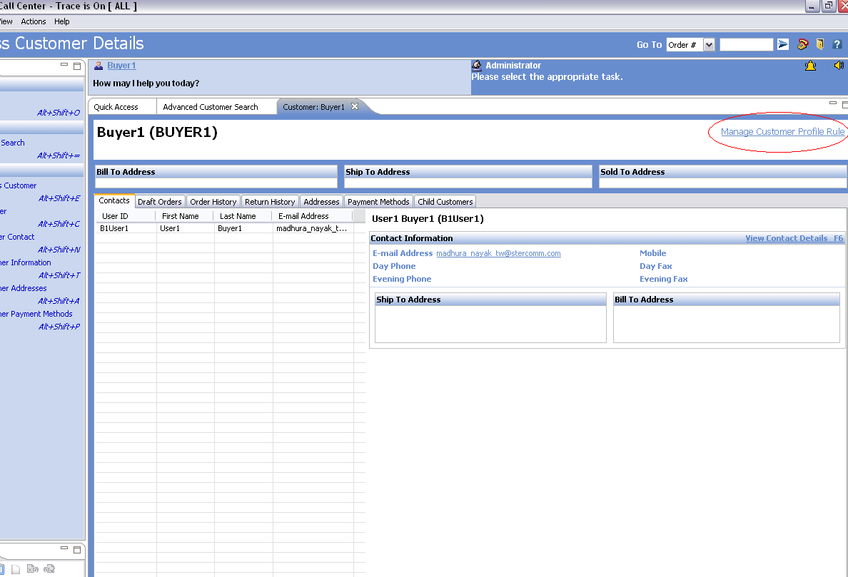

2.1.3.3 UI Validations
<This section is applicable to UI components. Provide the various validations that need to be applied for each field/control on the UI mock-up>N/A

2.1.3.4 Input Document
N/A

2.1.3.5 Output Document
<Provide a sample output XML with valid values for each attribute>N/A

2.1.3.6 Configuration
NA

2.1.3.1.1. <Insert Sub-Component Name>
<Elaborate input and output of each sub-component if applicable>N/A

- Input Document

- Output Document

2.2 Component
PCA Screen Design:- Customer Profile Rule

2.2.1 Components Overview
On Customer details page, click new link Manage Customer Profile Rule. On click, Customer Profile Rule screen opens to show all rules. Rules can be selected or removed by clicking checkbox and Update Rules button.

2.2.2 Component Design
- Screen Title: Customer Profile Rule
Localization Config Data: NA

Page Type: New Screen

On click of Manage Customer Profile rule, Action XPXShowCustomerProfileRuleAction will be called. XPXShowCustomerProfileRuleAction opens new editor which calls Screen CustomerProfileRulePanel. CustomerProfileRulePanelBehavior calls XPXGetRuleListWithParam service and create lines for every record returned by Service. On click of update Rules Button, Input XML is prepared and API manageCustomer is called which updates the table XPX_CUSTOMER_RULES_PROFILE.

- Editor:
com.xpedx.sterling.rcp.pca.customerprofilerule.editor.XPXCustomerProfileRuleEditor

- Actions:
  - Action:-com.xpedx.sterling.rcp.pca.customerprofilerule.action.XPXShowCustomerProfileRuleAction
Execution steps
On Click of manage profile Rule link, XPXShowCustomerProfileRuleAction is invoked.
This action invokes following editor com.xpedx.sterling.rcp.pca.customerprofilerule.editor.XPXCustomerProfileRuleEditor

  - Action:-
com.xpedx.sterling.rcp.pca.customerprofilerule.action.XPXShowCustomerProfileRuleAction
Execution steps
On Click of Update Rules button, XPXUpdateCustomerProfileRuleAction is invoked.
This action calls updateRules() on CustomerProfileRulePanelBehavior behavior.

- Page Composite:
  - PageId - com.xpedx.sterling.rcp.pca.customerprofilerule.screen.CustomerProfileRulePanel

  - Page Id- com.xpedx.sterling.rcp.pca.customerprofilerule.screen.CustomerProfileRuleLinePanel

- Behavior
  - Page Behaviour:-com.xpedx.sterling.rcp.pca.customerprofilerule.screen.CustomerProfileRulePanelBehavior

initPage() method will call Service XPXGetRuleListWithParam with input <XPXCustomerRulesProfile CustomerKey=””/>.

Click on Update Rules button, will call the updateRules method. Which calls the command manageCustomer with input
<Customer CustomerKey=””><Extn>
<XPXCustomerRulesProfileList Reset=”true”>
<XPXCustomerRulesProfile>
</XPXCustomerRulesProfileList>
</Extn>
</Customer>

handleApiCompletion() for XPXGetRuleListWithParam will be implemented to call CreateLine(). CreateLine() will create CustomerProfileRuleLinePanel for every record return by the service. In case of API manageCustomer, page will be refreshed.

  - Line Behaviour:-
com.xpedx.sterling.rcp.pca.customerprofilerule.screen.CustomerProfileRuleLinePanelBehavior

XPXCustomerRulesProfile element will be prepared to save the details to the table.

- Commands
  - XPXGetRuleListWithParam
Service gets all the Rule defn records and merge it with customer profile rules for the customer passed.
Input :-
<XPXCustomerRulesProfile CustomerKey=””/>

Output:-
<XPXRuleDefnList>
<XPXRuleDefn RuleDesc=" " RuleGroup="" RuleID=" " RuleKey="" RuleLongDesc=" "/>
</XPXRuleDefnList>

  - manageCustomer

Input Namespace:-
<Customer CustomerKey=””><Extn>
<XPXCustomerRulesProfileList Reset=”true”>
<XPXCustomerRulesProfile>
</XPXCustomerRulesProfileList>
</Extn>
</Customer>

Output Namespace:-
<Customer CustomerKey=””/>

- Messages: NA

- New Controls:

Control Name | Control Type | Source Binding | Target Binding | Theme | Mandatory | Data Type | Event associated | Hot Key | Localization  Config | Default Value
chkRuleSelected | Check Box | /XPXRuleDefn/@Selected | /XPXRuleDefn/@Selected | Default | NA | Check Box | None | NA | NA | None
stxtRuleDesc | StyledText | /XPXRuleDefn/@RuleDesc | NA | Default | NA | StyledText | None | NA | NA | None
txtParam1 | Text | XPXRuleDefn/@Param1 | XPXRuleDefn/@Param1 | Default | NA | Text | None | NA | NA | None
txtParam2 | Text | XPXRuleDefn/@Param2 | XPXRuleDefn/@Param2 | Default | NA | Text | None | NA | NA | None
txtParam3 | Text | XPXRuleDefn/@Param3 | XPXRuleDefn/@Param3 | Default | NA | Text | None | NA | NA | None
btnUpdateRules | Button | NA | NA | Default | NA | Button | com.xpedx.sterling.rcp.pca.customerprofilerule.action.XPXUpdateCustomerProfileRuleAction | NA | NA | None

- Related Tasks: NA

2.1.3.1 UI Design

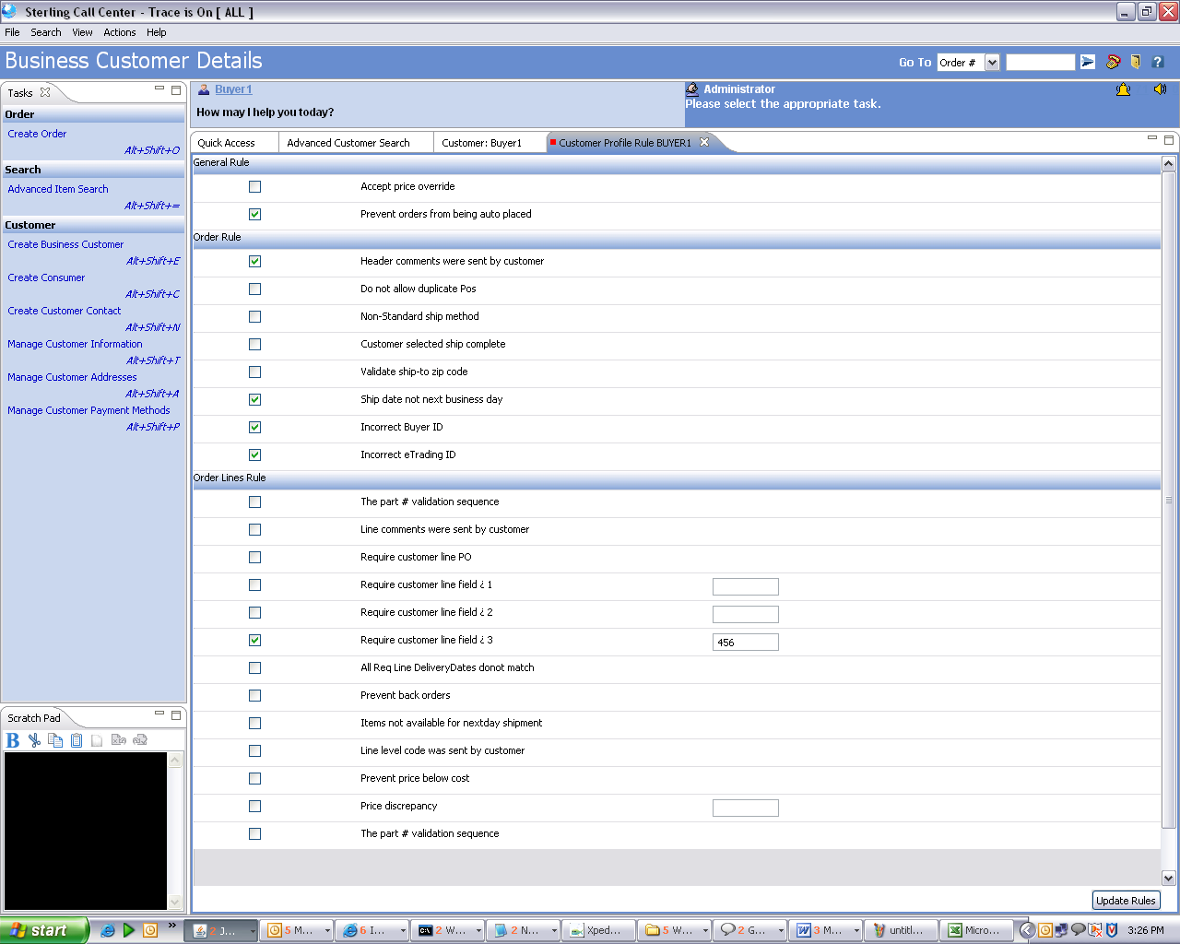

2.2.3.3 UI Validations
<This section is applicable to UI components. Provide the various validations that need to be applied for each field/control on the UI mock-up>N/A

2.2.3.4 Input Document
<Customer CustomerID="" CustomerKey=""
CustomerType="" OrganizationCode="">
<BuyerOrganization OrganizationCode="" OrganizationName=""/>
</Customer>

2.1.3.5 Output Document
<Provide a sample output XML with valid values for each attribute>N/A

2.2.3.6 Configuration

XPXGetRuleListWithParam
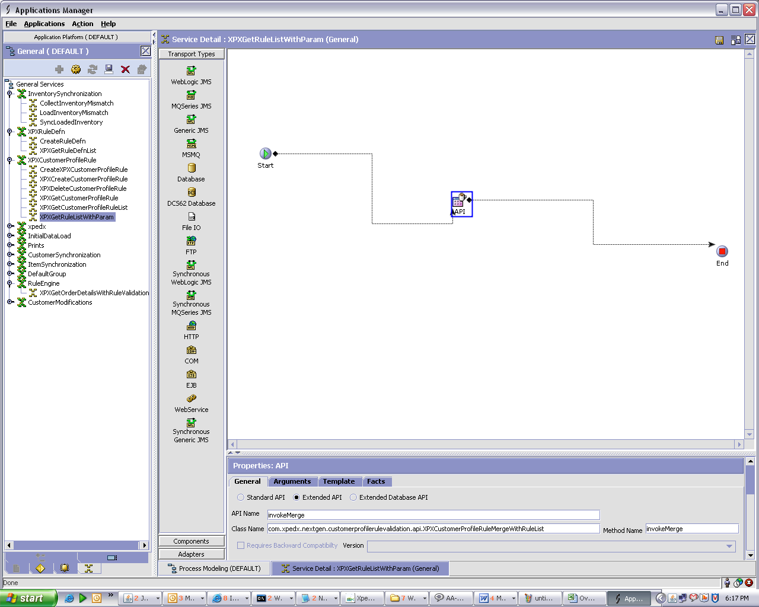

Extended API :-
API Name:- invokeMerge
Method Name :- invokeMerge
Class Name:- com.xpedx.nextgen.customerprofilerulevalidation.api.XPXCustomerProfileRuleMergeWithRuleList

2.2.3.1.1. XPXGetRuleListWithParam
<Elaborate input and output of each sub-component if applicable>
- Input Document
<XPXCustomerRulesProfile CustomerKey=””/>

- Output Document

<XPXRuleDefnList>
<XPXRuleDefn RuleDesc=" " RuleGroup="" RuleID=" " RuleKey="" RuleLongDesc=" "/>
</XPXRuleDefnList>

3. Database Extensions
NA

4. Exception and Error Handling
This component will throw an InvalidCategory exception if the category to which the item is to be attached has not been created.
<Provide the list of exceptions (business and system exceptions) the component can throw>

5. Security Aspects
<Provide details on the security aspects of this implementation. Where would these security components reside, what will be encryption that will be used and any audit trails required>N/A

5.1 Ownership
5.2 Encryption
5.3 Audit Trail
5.4 Other Security Aspects

6. Dependencies
<For issues that are dependent on customer: Record all dependencies made for this design including business requirement, performance and technical factors, etc. in JIRA and list the JIRA tickets numbers here

JIRA no | desc | To be validated by  (Team/Person) | Status | Implications if incorrect

<For issues those aren’t dependent on customer: Record all dependencies made for this design including business requirement,performance and technical factors, etc. here

Include only those that are not already documented in SDD If there are changes in SDD, reference the specific dependency and state the revised assumption. New assumption should be approved prior to design review> XReference Section 2.8 – Assumptions in Functional Design Document.

No. | Assumption | To be validated by  (Team/Person) | Status | Implications if incorrect

7. Unit Test Cases
<Elaborate unit test cases for all the components. Every unit test case should include description, pre-requisites, expected results, etc. The below section should repeat for each component>

7.1 <Insert Component Name>

Test No. | Test Description | Execution Instructions | Expected Result

